Securing Data Using Image Steganography

And Encryption Techniques

|  |  |
| --- | --- |
| **1st Arju satish lokhande** Computer Science and Engineering Jhulelal Institute of Technology Nagpur, India [jitcselokhandearju97@gmail.com](mailto:jitcselokhandearju97@gmail.com) | **2nd Diksha devraoji shelke** Computer Science and Engineering Jhulelal Institute of Technology Nagpur, India [diksha4997@gmail.com](mailto:diksha4997@gmail.com) |
| **3rd Prachi sheshrao pagare** Computer Science and Engineering Jhulelal Institute of Technology Nagpur, India  [prachipagare105@gmail.com](mailto:prachipagare105@gmail.com) | **4th Pooja krushnarao jawade** Computer Science and Engineering Jhulelal Institute of Technology  Nagpur, India [Poojajawade89@gmail.com](mailto:Poojajawade89@gmail.com) |

**Abstract:** Nowadays, the community has important roles for transferring records precisely and quick from source to a destination. In this project we are develop new algorithm to Image Steganography Using Kmeans & Encryption technique Steganography is defined as the study of invisible communication. Steganography usually deals with the ways of hiding the existence of the communicated data in such a way that it remains confidential. It maintains secrecy between two communicating parties. In image steganography, secrecy is achieved by embedding data into cover image and generating a stego-image. There are different types of steganography techniques each have their strengths and weaknesses. In this paper, we review the different security and data hiding techniques that are used to implement a steganography such as LSB, ISB, MLSB etc. Most of the existing steganographic algorithms are performed in pixel domain as it provides more embedding space (capacity), reliability and controllability in encoding/decoding of the hidden message.

**Keywords:** Steganography, Stego- image, LSB, ISB, MSB

**INTRODUCTION:**

* Steganography, which is Greek for "covered writing," is a subset of the emerging discipline of information hiding. It is the science of transmitting a message between two parties in such a manner that an eavesdropper will not be aware that the message exists. Unlike cryptography, which seeks to hide the content of the message, with steganography we seek to hide the existence of the message. Of course, steganography and cryptography can be used in conjunction, so that message content may be protected cryptographically, even if the steganographic "shield" fails and the existence of the message is discovered.
* Today digital data can be easily copied and multiplied without information loss. It has become imperative to verify the owner of a digital data, to identify illegal copies of the multimedia content and to prevent unauthorized distribution. Information hiding techniques have thus recently received great attention from the research community.
* Stegan ography involves hiding of text, image or any sensitive information inside another image, video or audio in such a way that an attacker will not be able to detect its presence.
* Steganography is, many times, confused with cryptography as both the techniques are used to secure information.
* The difference lies in the fact that steganography hides the data so that nothing appears out of ordinary while cryptography encrypts the text, making it difficult for an outsider to infer anything from it even if they do attain the encrypted text.
* Both of them are combined to increase the security against various malicious attacks. Image Steganography uses an image as the cover media to hide the secret message.
* In this project, we propose an image steganography method which clusters the image into various segments and hides data in each of the segment. Various clustering algorithms can be used for image segmentation. Segmentation involves huge set of data in the form of pixels, where each pixel further has three components namely red, green and blue. K-means clustering technique is used to get accurate results. Therefore, we use K-means clustering technique to get accurate results in a small time period.

# METHODOLOGY:

## In this project, we propose an image steganography method which clusters the

image into various segments and hides data in each of the segment. Various clustering algorithms can be used for image segmentation. Segmentation involves huge set of data in the form of pixels, where each pixel further has three components namely red, green and blue. K-means clustering technique is used to get accurate results. Therefore, we use K- means clustering technique to get accurate results in a small time period.

1. **RESULT AND ANALYSIS**

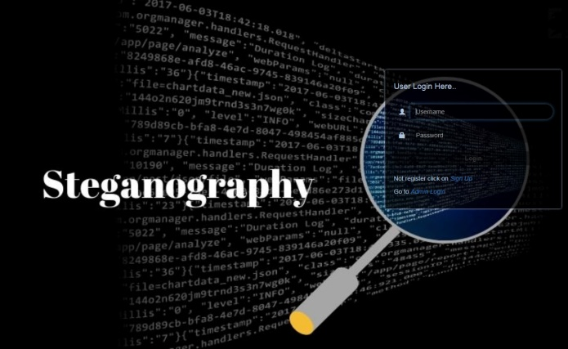 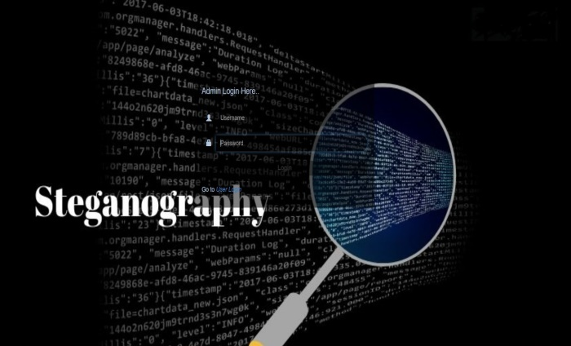

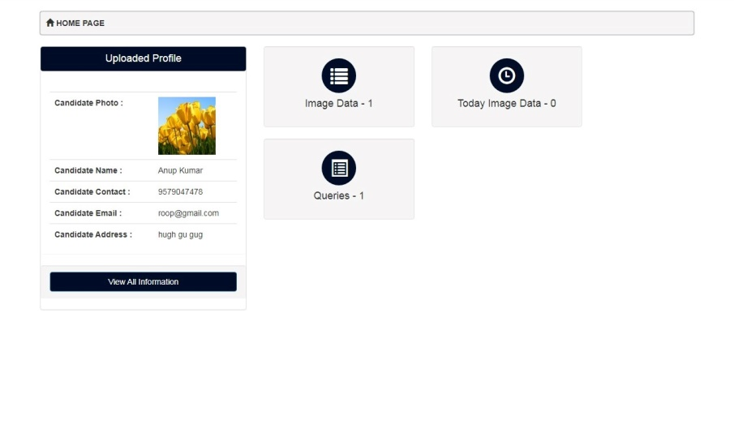

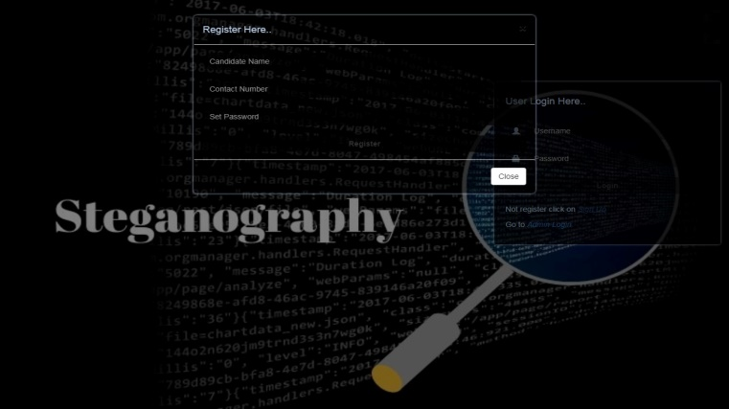

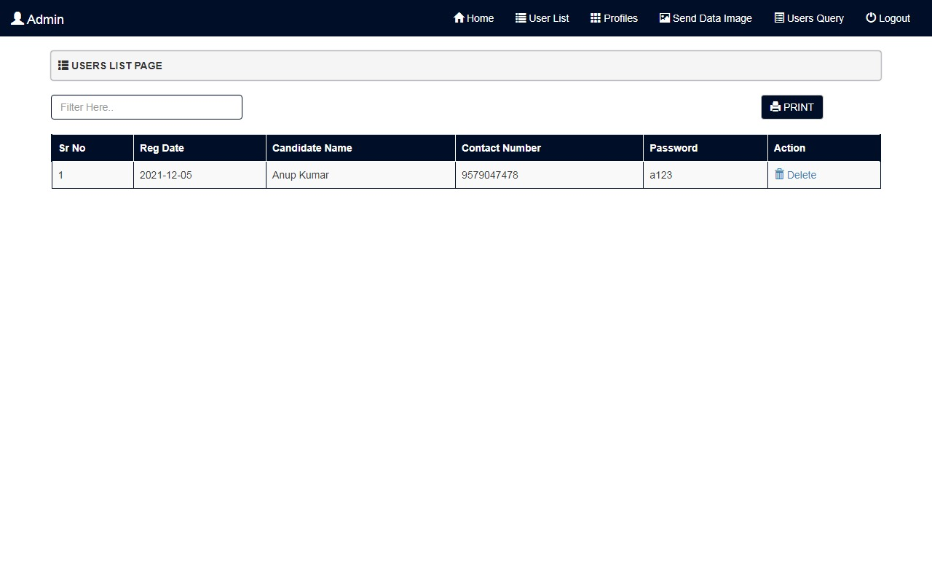

1. **CONCLUSION:**

In this research work we reviewed many papers on steganography techniques. These papers are good enough and have wide future scope. By reviewing these papers, we observed that most of the steganography work is done in the year 2012 & 2013. In these years, LSB is the most widely used technique for steganography. Some researchers have also used the techniques like water marking, distortion technique, spatial technique, ISB, MSB in their work and provided a strong means of secure information transmission. Most of the papers that are discussed here are taken from IEEE Explore, AICCSA, IJET, IJCSE, IJCA etc. This review paper is enough for them to start their work in this field. The different security and data hiding techniques are used to implement steganography using LSB, ISB, MLSB.

# FUTURE SCOPE:

Hiding a file, message or even a video within another file can be an effective way for malware authors to obscure their own payload or to exfiltrate user data. Given the popularity of image sharing on social media sites and the prevalence of image-based advertisement, we expect the recent trend of using steganography in malware to continue. These papers provide a lot of help to the initiator for starting their work in this field. In further research we are going to use more advance schemes like steganography with some hybrid cryptographic algorithm for enhancing the data security.

# REFERENCE:

1. Yang, Chunfang., Liu, Fenlin., Luo, Xiangyang., and Zeng, Ying., “Pixel Group Trace Model-Based Quantitative Steganalysis for Multiple Least-Significant Bits Steganography”, IEEE Transactions on Information Forensics and Security, Vol. 8, No. 1, January 2013.
2. Swati malik, Ajit “Securing Data by Using Cryptography with Steganography” International Journal of Advanced Research in Computer Science and Software Engineering, Volume 3, Issue 5, May 2013.
3. Ishwar jot Singh, J.P Raina, “Advance Scheme for Secret Data Hiding System using Hop field & LSB” International Journal of Computer Trends and Technology (IJCTT) – volume 4 Issue 7–July 2013.
4. G. Manikandan, N. Sairam and M. Kamarasan “A Hybrid Approach for Security Enhancement by Compressed Crypto- Stegno Scheme “, Research Journal of Applied Sciences, Engineering and Technology 4(6): 608-614, 2012.
5. Shabir A. Parah, Javaid A. Sheikh, G.M. Bhat, “Data Hiding in Intermediate Significant Bit Planes, A High Capacity Blind Steganographic Technique”, International Conference on Emerging Trends in Science, Engineering and Technology, pp.192-197, July 2012

[6] Michel K. Kulhandjian, Dimitris A. Pados, Ming Li, Stella N. Batalama, and Michael J. Medley, “Extracting spread-

spectrum hidden data from digital media “, IEEE transactions on information forensics and security, vol. 8, no. 7, july 2013.

[7]Chang, Chin-Chen., Lin, Iuan-Chang., and Yaun-Hui YU., “A new Steganographic method for color and gray scale

image hiding”, Computer Vision and Image Understanding, ELSEVIER, Vol. 107, No. 3, pp. 183-194,2007.

[8]Bailey, K., and Curran, K., “An Evaluation of Image Based Steganography Methods”, Journal of Multimedia Tools and

applications, Vol. 30, No. 1, pp. 55-88, 2006.

[9]Adnan Gutub, Ayed Al-Qahtani, Abdulaziz Tabakh, “Triple-A: Secure RGB Image Steganography Based on

Randomization”, International Conference on Computer Systems and Applications (AICCSA-2009), pp: 400-403, 10-13 May 2009.

[10]R.Amirtharajan, Sandeep Kumar Behera, Motamarri Abhilash Swarup, Mohamed Ashfaaq and John Bosco Balaguru

Rayappan , “Colour Guided Colour Image Steganography” Universal Journal of Computer Science and Engineering Technology , 16-23, Oct. 2010, pp. 2219-2158.

[11] Anil Kumar, Rohini Sharma,”A Secure Image Steganography Based on RSA Algorithm and Hash-LSB Technique

“,International Journal of Advanced Research in Computer Science and Software Engineering, Volume 3, Issue 7, July 2013.

[12] Gutub, A., Al-Qahtani, A., and Tabakh, A., “Triple-A: Secure RGB image steganography based on randomization”,

Computer Systems and Applications, AICCSA 2009, IEEE/ACS, pp. 400 – 403, 2009... [13] Dr. Fadhil Salman Abed “A

Proposed Method of Information Hiding Based on Hybrid Cryptography and Steganography “, IJAIEM, Volume 2, Issue 4,

April 2013.

[13]K. S. Babu, K. B. Raja, K. Kiran Kumar, T. H. Manjula Devi, K. R. Venugopal and L. M. Pataki, “Authentication of secret

information in image steganography”, IEEE Region 10 Conference, TENCON- 2008, (2008) November, pp. 1-6

[14]M. Chaumont and W. Puech, “DCT-Based Data Hiding Method to Embed the Color Information in a JPEG Grey Level

Image”, 14th European Signal Processing Conference (EUSIPCO 2006), Florence, Italy, copyright by EURASIP,

(2006) September 4-8.

[15]A. M. Hamid and M. L. M. Kiah, “Novel Approach for High Secure and High-Rate Data Hidden in the Image Using

Image Texture Analysis”, International Journal of Engineering and Technology (IJET): 0975-4042, (2009).

## [16]Chandu Vaidya and Prashant Khobragade. “ Data Security in Cloud Computing”. International Journal on

## Research and Innovation Trends in Computing and Communication, 2015. Volume ,3. Issue.5. ISSN: 2321-

## 6169. pp: 167-170.

## [17]Sampritha S. Shetty “Image Steganography Using K-Means and DES Algorithm” International Journal of

## Research in Engineering, Science and Management Volume-3, Issue-6, June-2020 [www.ijresm.com](http://www.ijresm.com/) | ISSN

## (Online): 2581-5792

[18]Vaidya, C., and Bhure, K. S. (2020). Survey on Cloud Computing Load Balancing. *i-manager's Journal on*

*Cloud Computing,* 7(1), 32-46. <https://doi.org/10.26634/jcc.7.1.17156>

## [19]Chandu Vaidya, Prashant Khobragade and Ashish Golghate, "Data Leakage Detection and Security in

## Cloud Computing", GRD JournalsGlobal Research Development Journal for Engineering,Volume 1,Issue

## 12,November 2016.

## 